**Basic Questions**

**Question 1. What is computer?**

**Answer:-** A computer is a man made electronic machine which stores, read and processes data to produce meaningful information as output. It is made of English word ‘to compute’. It operates under the control o f a set of instruction that is stored in its memory unit. A computer accepts data from an input devices and processes in into useful information which it displays on its output device.

A computer is a collection of hardware and software components that helps us to accomplish many different tasks.

A computer is an electronic device in which we put data through keyboard or mouse and it gives output through monitor screen.

**Question 2. Who is the father of computer?**

**Answer:-** Mr. Charles Babbage. Invention in 1890

**Question 3. What is the Full form of COMPUTER?**

**Answer:-**

* C = Common/Calculate
* O= Operating/ Oriented(learning)
* M= Machine/ Memory
* P= Particular/ Processor
* U= Used In/ United(combine and user under)
* T= Trade/ Technical
* E= Educational
* R= Research

**Question 4. Parts of computer?**

**Answer:-** 1. Software 2. Hardware

1. Software:- Software is a program that enables a computer to perform a specific task, as opposed to the physical components of the system (hardware).

For eg. Ms Paint, Whatsaap, etc.

2. Hardware:- Computer hardware includes the physical parts of a computer, such as the case, central processing unit, monitor, keyboard, computer data storage, graphics card, sound card, speakers and motherboard.

**Question 5. Generations of Computer:**

**Answer:- 1. The First Generation:1946 to 1958**

The first generation computer were slow, ex-pensive and often undependable and used Vaccum Tubes in CPU’s.

**2. The Second generation: 1959 to 1964**

Transistor replaces vaccum tubes and unhered in the second generation of computer

**3. The Third Generation: 1965 to 1970**

Integrated Circuits (IC) are introduced that have started replacing transistor.

**4. The Forth Generation: 1971 to 1989**

This generation can be characterized by both the jumps to monolithic integrated circuits(millions of transistor put onto one integrated circuits chip) and the invention of the microprocessor.

**Fifth Generation of Computers**

**The main characteristics of fifth generation of computers (the present and the future)**

* Main electronic component: based on artificial intelligence, uses the Ultra Large-Scale Integration (ULSI) technology and parallel processing method.
  + **ULSI** – millions of transistors on a single microchip
  + **Parallel processing method** – use two or more microprocessors to run tasks simultaneously.
* Language – understand natural language (human language).
* Power – consume less power and generate less heat.
* Speed – remarkable improvement of speed, accuracy and reliability (in comparison with the fourth generation computers).
* Size – portable and small in size, and have a huge storage capacity.
* Input / output device – keyboard, monitor, mouse, trackpad (or touchpad), touchscreen, pen, speech input (recognise voice / speech), light scanner, printer, etc.
* Example **–** desktops, laptops, tablets, smartphones, etc.

**Question 6. How to Start Computer?**

Main Switch ON

🡫

Then C.P.U Button ON

🡫

Then Monitor/ LCD Button ON

🡫

Then, your PC will ON

Icons Desktop Screen

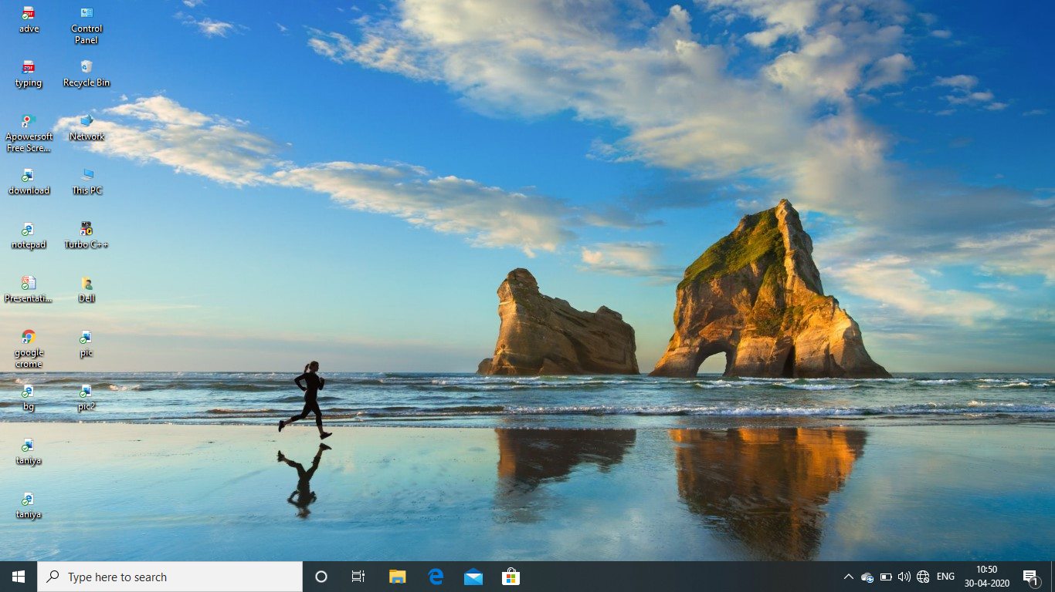

Start Button Taskbar Notification Area

**Question 7. How to Shut Down any PC?**

**Answer:-** Two Methods of Shut down:-

|  |  |
| --- | --- |
| Start Button  Shut Down/ Log off | On the Desktop Screen  Press Alt + F4  Then, Ok/ Enter |

**Question 8. What is MS Paint?**

**Answer:-** Microsoft Paint, also called MS Paint or simply Paint is a computer program made by [Microsoft](https://simple.wikipedia.org/wiki/Microsoft). It allows people to create picture files as well as edit picture files saved on their computer. Microsoft Paint is also a program for adding texts to images saved on a computer.

**Question 9. How to open MS Paint?**

**Answer:-** Three Method of Open MS Paint:-

|  |  |
| --- | --- |
| Start Button  All programs  Accessories  Paint | Win. +R  Type- Mspaint  Enter/Ok |
| Win. + R  Type- Pbrush  Enter/Ok | |

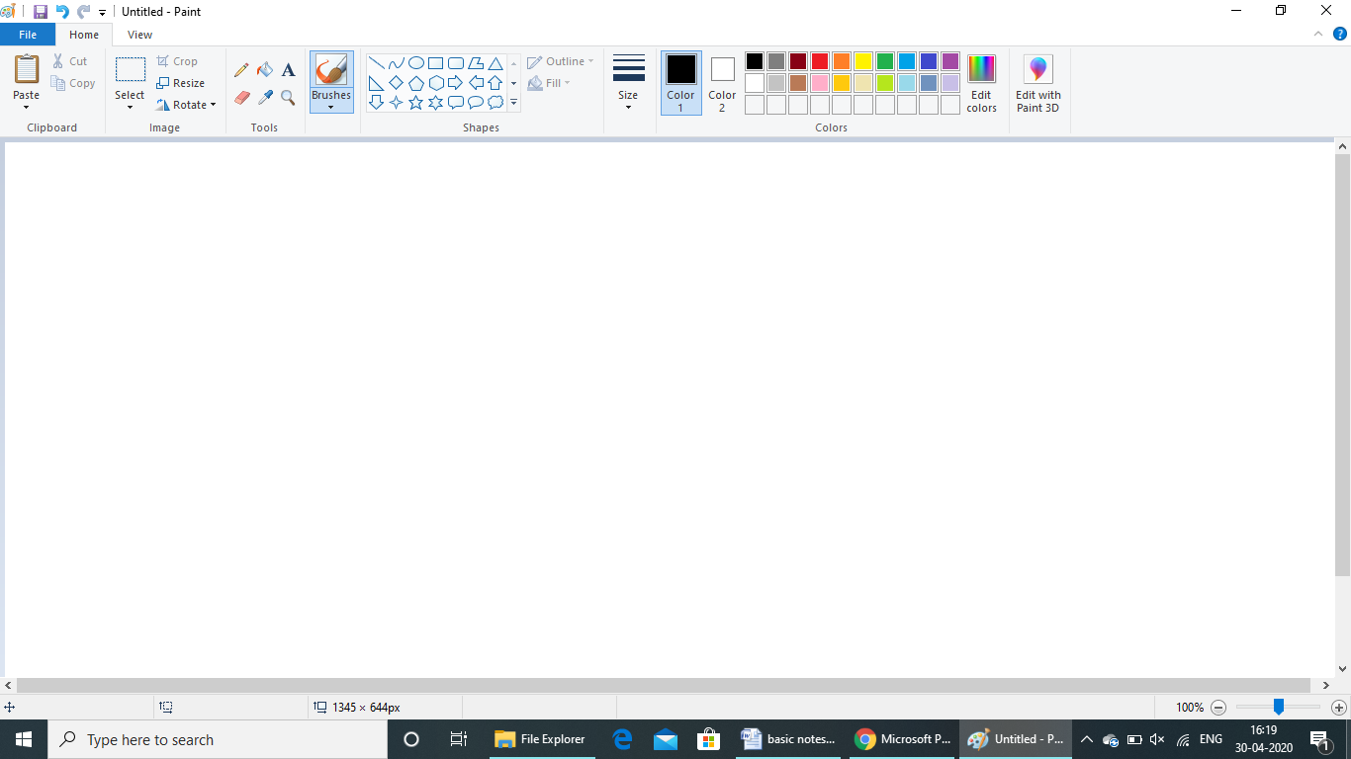**Overview of MS Paint**

Title Bar Menu Bar/Tab Bar Ribbon Bar

Drawing Area Status Bar

**ALL WINDOWS AND DATES**

|  |  |
| --- | --- |
| **Windows** | **Dates** |
| Window 1.01 | 20, Nov. 1985 |
| Window 1.02 | May,1986 |
| Window 1.03 | Aug. 1986 |
| Window 1.04 | April. 1987 |
| Window 2.03 | 9 Dec. 1987 |
| Window 2.10 | 27, May. 1988 |
| Window 2.11 | 13, March. 1989 |
| Window 3.0 | 22, May.1990 |
| Window 3.1 | April, 1992 |
| Window NT 3.1 | 27, July. 1993 |
| Window for wordgroup 3.11 | Nov. 1993 |
| Window 3.2 | 22, Nov. 1993 |
| Window NT 3.5 | 21, Sep. 1994 |
| Window NT 3.51 | 30, May. 1995 |
| Window 95 | 24, Aug. 1995 |
| Window NT 4.0 | 24, Aug. 1996 |
| Window 98 | 25, July. 1998 |
| Window 2000 | 17, Feb. 2000 |
| Window ME | 14, Sep. 2000 |
| Window XP | 25, Oct. 2001 |
| Window XP Professional X64 | 25, April. 2005 |
| Window Vista | 30, Jan. 2007 |
| Window 2007 | 22, July. 2009 |
| Window 2008 | 26, Oct. 2012 |
| Window 8.1 | 17, Oct. 2013 |
| Window 10 | 29, July. 2015 |
| Window 11 | 05, Oct., 2021 |

**Computer Test**

**Q1. What is Computer?**

**Ans.**

**Q2. What is the Full form of Computer?**

**Ans.**

**Q3. Write Five Parts of Computer?**

**Ans.**

**Q4. Who is the father of computer?**

**Ans.**

**Q5. IT stands for:-**

**A) Information Techonology B) Integrated Technology**

**C) Intelligence Techonology D) Interesting Technology**

**Q6. What is the shortcut key of shut down?**

**Ans.**

**Q7. CPU stands for:**

**Ans.**

**Q8. Which of the following will you use to select any irregularly shaped part of the picture?**

**A. Free-Form Select B. Select**

**C. Eraser D. Fill with Color**

**Q9. To zoom in on a section of your picture, you should use**

**A. Magnifier B. Free-Form**

**C. Brush D. Eraser**

**Q10. It is a drawing program you can use to create drawing or edit digital pictures using different file formats.**

**A. Ms Word B. Word pad**

**C. Paint D. Movie Maker**

**Q11. How many types of alignment available in word pad?**

**A. 1 B. 2**

**C. 3 D. 4**

**E. None of these**

**Q12. To undo the last word, press**

**Q13. To save a document , press**

**Q14. Which key is used to select all the text in the document?**

**A. Ctrl + A B. Ctrl + F**

**C. Ctrl + T D. Ctrl + S**

**Q15. Which one of the following should be clicked to save the existing Notepad window?**

**A. Edit B. Save**

**C. Format D. Save As**

**Q16. Write the name of all tags following :-**

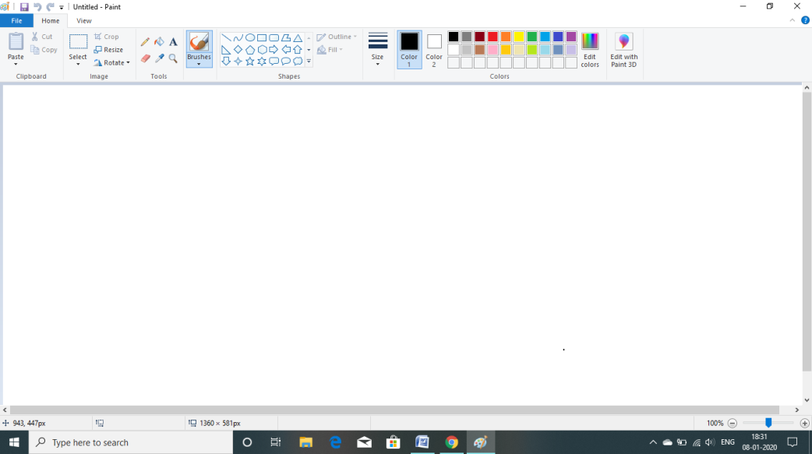

**Basic Questions and Answers**

**Q 1- What is the first Computer’s Name?**

**Ans-** ENIAC (Electronic Numerical Integrator and Calculator).

**Q 2- Computer Day is Celebrated on….**

**Ans-** 2 Dec.

**Q 3**- **To Find information about image**

**Ans-** Website-: Search by Image / Reverse Search Image

**Q 4**- **Parts of CPU**

**Ans-** ALU (Arithmetic Logical Unit) & CU (Central Unit)

**Q 5- The valid measurement unit of memory ?**

**Ans-** KB, MB, GB….

**Q 6- Bits stands for**

**Ans-** Binary Digits

**Q 7- Main memory are**

**Ans-** RAM or ROM

**Q 8**- **How much data can be stored in a CD?**

**Ans-** 700 MB

**Q 9**- **MAC stands for**

**Ans-** Media Access Control

**Q 10**- **Physical arrangement of computer network is called**

**Ans-** Topology

**Q 11**- **From which generation O.S (Operating System) were developed?**

**Ans-** 3rd

**Q 12**- **USB stands for**

**Ans-** Universal Serial Bus

**Q 13- First generation of computer was based on which technology?**

**Ans-** Vaccum Tubes

**Q 14-** **Time period of Ist generation?**

**Ans-** 1946-1959

**Q 15- PCB stands for?**

**Ans-** Printed Circuit Board

**Q 16-** **Parts of CPU**

**Ans-** ALU & CU

**Q 17-** **Bits stands for**

**Ans- Bi**nary Digi**ts**

**Q 18-** **Main memory are**

**Ans-** RAM or ROM

**Q 19-** **How much data can be stored in a CD?**

**Ans-** 700 MB

**Q 20-** **The location of the resource on internet is given by its**

**Ans-** URL

**Q 21- MAC stands for?**

**Ans-** Media Access Control

**Q 22- Read/Write Memory**

**Ans**- RAM

**Q 23- What is Ram?**

**Ans-** Ram only ensure that too many apps to table opened at same time run smoothly.

**Basic Shortcut Keys**

|  |  |
| --- | --- |
| **Win** | Open/Close start menu |
| **Win + A** | Open Action Center |
| **Win + D** | Display and Hide the Desktop |
| **Win + E** | Open File Explorer |
| **Win + I** | Open Setting App |
| **Win + L** | Lock Device |
| **Win + T** | Open New tab in browser |
| **Win + M/W** | Minimize All window |
| **Win + V** | Open Clipboard Bin or view Clipboard history |
| **Win + Esc** | Open Start Menu |
| **Win + X** | Open Quick Link Menu |
| **Win + PrtScn** | Capture Full Screenshot in the "Screenshot" Folder |
| **Win + . Or ; or ,** | Open Emoji Panel |
| **Win + Shift + S** | Capture part of the screen with snip & Sketch |
| **Win + Number(0-9)** | Open App in number position from the taskbar |
| **Win + Shift + M** | Restore minimized windows on the desktop |
| **Win + Arrows** | Minimise, Maximise, Left Side, Right Side the active application |
| **Win + (+) or (-)** | ON Magnifier |
| **Win + S or Q** | Open Search |
| **Win + Alt + D** | Open Date and Time in the taskbar |
| **Win + Tab** | Open task view |
| **Win + Ctrl + F4** | Close Active virtual desktop |
| **Win + Ctrl + D** | Create New Virtual Desktop |
| **Win + R** | Open Run Command |
| **Win + Home** | Minimize or Maximize all but the active desktop window |
| **Shift + Delete** | Permanent Delete |
| **Alt + P** | show matter before open any file or view preview pane in my files. |
| **Alt + F4** | Close the running program |
| **Ctrl + Backspace** | Delete a word at a time in all software |
| **F1** | Get Help |
| **F2** | Rename Folder |
| **F3** | Search a word on Web Browser / Search any Application on Desktop / Search any file on My files |
| **F5** | Refresh |
| **F6** | Jump to URL (Web Browser) |
| **F11** | Full Screen Mode |
| **F12** | Open a save As |
| **Ctrl + Shift + N** | New Folder |
| **Ctrl + Shift + T** | Re-open last closed tab on browser |

**Tips and Tricks**

**Extensions**

|  |  |  |
| --- | --- | --- |
| Applications | Run Command | Extensions |
| Paint | Pbrush / Mspaint | .png |
| Notepad | Notepad | .txt |
| Wordpad | Wordpad | .rtf (Rich Text File) |
| MS-Excel | Excel | .xlsx |
| MS-Powerpoint | Powerpnt | .ppt |
| Photoshop | Photoshop | .psd |
| Corel Draw | Coreldrw | .cdr |

* **Hide any folder on Desktop Screen**

|  |  |
| --- | --- |
| New  ↓  Folder  ↓  Rename the folder  ↓  Repeat Rename  ↓  Enter Alt + 0160  ↓ | So, Name will not show  ↓  Properties  ↓  Customize  ↓  Change Icon  ↓  Choose Blank Icon |

* **How to hide all Desktop Icons**

|  |
| --- |
| Right click on Desktop Screen  🡫  View  🡫  Show Desktop Icons (Untick) |

* **Tick (✓)Symbol on MS- Word**

|  |
| --- |
| Insert  ↓  Symbols  ↓  **Wingding font**  ↓  Last line in the symbols box |

* **Paste as Hyperlink on MS-Word.**

Paste as Hyperlink means to create your own link.

Firstly, Write the name with which you want to create the link, then the paragraph.

Then, Save that file

Then, Move to another page with the name and paragraph you typed

Then, Copy the word on which the link is to be placed

Then, Save that file again

Then, Where to put the link, paste it as hyperlink

* **Pronounciate any Number in Google Chrome.**

|  |
| --- |
| Google  ↓  Type any big/small “no. =English” |

* **To Increase the size of line in Paint.**

|  |
| --- |
| Draw a line  ↓  Ctrl + (+) (Increasing)/ Ctrl + (-) (Decreasing) |

* **How to burn CD/DVD without any Software**

Step 1- Insert Blank CD/ DVD

Step 2- Open My files

Step 3- Click on the file you want to burn,

then click on the option of Burn to Disc in the Share tab,

then right click on the blank space in the CD drive and

then Burn to Disc

* **Types of Keyboard:-**
  + Standard Keyboard
  + Internet Keyboard
  + Multimedia Keyboard
  + Gaming Keyboard

* **How to view properties of any software or file.**

|  |
| --- |
| Click on software/ file  🡫  press Alt + Enter key  🡫  Done |

* **Rupees (₹) sign in MS-Word.**

|  |
| --- |
| Type 20b9  🡫  Select 20b9  🡫  Press alt+X |

* **How to make snake in Paint.**

|  |
| --- |
| Select the picture with rectangular selection  🡫  Select transparent selection (✓)  🡫  Move the picture with holding shift |

* **How to Hide Taskbar?**

|  |
| --- |
| Right Click on Taskbar  🡫  Click on last option (Taskbar Setting)  🡫  Automatic hide the taskbar in desktop screen (ON) |

* **Make shortcut key of Desktop files/ application.**

|  |
| --- |
| Right click on file or application  🡫  Properties  🡫  Shortcut  🡫  Shortcut key  🡫  Write any shortcut key |

* **Make a shortcut key of software which are not present in desktop screen**

|  |
| --- |
| Start button  🡫  Right click on software  🡫  More  🡫  Open file location  🡫  Right click on software  🡫  Properties  🡫  Shortcut  🡫  Shortcut keys  🡫  Enter shortcut |

* **Window 10 Laptop touchpad fingers action**
  + One Finger
    - Move cursor / left click
  + Two Fingers
    - Right Click
    - Page scroll
  + Three Fingers
    - ON Cortona
    - Switch Window
  + Four Fingers
    - Notification Area open
* **Hindi & English Typing Together**

|  |
| --- |
| Right click on tab bar  🡫  Customise Quick Access Toolbar  🡫  Customise  🡫  Fonts  🡫  Select font style  🡫  Set Shortcut key |

* **Edit video with default window software**

|  |
| --- |
| 🡫  Video Editor (Default window software) |

* **Print document or file path on hard / soft copy in MS-Word**

|  |
| --- |
| Set Footer from insert Tab  🡫  In, Header & Footer tool- select Quick Parts  🡫  Fields  🡫  Categories- Document Information  🡫  Field Name- File name  🡫  Click on-add path to filename (✓)  🡫  ok |

* **Divide sign (⟌) in MS- Word**

|  |
| --- |
| Insert  🡫  Symbols  🡫  Font- cambrai math, subsort- Miscellous Mathematical symbol |

* **Lock any drive**

|  |
| --- |
| Right click on Drive  🡫  Turn on Bitlocker  🡫  Set Password |

* **Snip & Sketch Screenshot**

|  |
| --- |
| + Shift + S  (Before saving the screenshot, we can sketch on it) |

* **Units of Computer Memory Measurements**

|  |  |
| --- | --- |
| 1 Bits | Binary Digit |
| 4 Bits | Nibble |
| 8 Bits | Bytes |
| 1024 Bytes | 1 KB (Kilo Byte) |
| 1024 KB | 1 MB (Mega Byte) |
| 1024 MB | 1 GB (Giga Byte) |
| 1024 GB | 1 TB (Terra Byte) |
| 1024 TB | 1 PB (Peta Byte) |
| 1024 PB | 1 EB (Exa Byte) |
| 1024 EB | 1 ZB (Zetta Byte) |
| 1024 ZB | 1 YB (Yotta Byte) |
| 1024 YB | 1 Bronto Byte |
| 1024 Bronto Byte | 1 Geop Byte |

* **Symbols in MS-Word**

|  |  |
| --- | --- |
| **Copyright Symbol** | (c) |
| **Register Symbol** | (R) |
| **Trade Mark Symbol** | (TM) |

* **How to use insert key in MS-Word**

|  |
| --- |
| File  🡫  Word option  🡫  Advance  🡫  🗹 Use the insert key to control overtype mode  🗹 Use overtype mode |

* **Video Editor Software Name**

|  |
| --- |
| Open Shot |
| Window movie maker (Window essential software |
| Hit Film express |
| Shortcut |
| Filmora (Popular) |

**Useful Websites**

* **Unscreen.com**
  + Remove background from the video
* **Pacman doodle game**
  + To Play online games
* **Search by Image / Reverse search Image**
  + To See Information about image.
* **autoDraw**
  + In this website we can draw anything and acc. To our drawing the result will seen.
* **Ai picture Restore**
  + Restore destroyed picture to clean picture
* **Ai picture colorizer**
  + Convert Back & White picture to colored picture.
* **Dictation.io**
  + Type with speak
* **I2ocr.com**
  + Convert image to text
* **Photopea.com**
  + All features of photoshop
* **Flipanim.com**
  + For making animation
* **W3school.com**
  + For learn programming language
* **Archive.org**
  + Non-profit library
* **Edx.org**
  + Free course (Languages, computer Sci. for college students)
* **Smallpdf**
  + For convert pdf to other format or vice versa
* **Whatsaap web**
  + To open whatsaap in PC
* **Youtube Downloader**
  + To download youtube videos
* **Screenshot.guru**
  + Screenshot a complete webpage
* Onlineocr.net
  + To convert pdf to text, word, etc file formate

**Shortcut Keys (MS- Word)**

**Ctrl + A** = To Select All Entire matter

**Ctrl + B** = To Bold selected matter

**Ctrl + C** = To Copy Selected matter

**Ctrl + D** = To set Font Style of Selected matter

**Ctrl + E** = To Centre alignment of selected matter

**Ctrl + F** = To Find any matter

**Ctrl + G** = To Go to wanted Word, page no., Line no., Section no

**Ctrl + H** = To replace last find matter

**Ctrl + I** = To Italic Selected matter

**Ctrl + J** = To Justify (Both side to a paragraph is equal)

**Ctrl + K** = To Hyperlink

**Ctrl + L** = To left Alignment

**Ctrl + M** = To increase Indent of selected paragraph

**Ctrl + N** = To Create New File

**Ctrl + O** = To Open already existing file

**Ctrl + P** = To Print

**Ctrl + Q** = To decrease Indent of selected paragraph

**Ctrl + R** = To Right alignment

**Ctrl + S** = To Save Document

**Ctrl + T** = To Hanging indent

**Ctrl + U** = To Underline selected matter

**Ctrl + V** = To Paste last cut/copy matter

**Ctrl + W** = To Close Current open file

**Ctrl + X** = To Cut selected matter

**Ctrl + Y** = To Redo

**Ctrl + Z** = To Undo

**Ctrl + Home** = Go to First page

**Ctrl + Shift + Home** = Select Upper part of the cursor

**F7** = Spelling & Grammar Check

**F8** = Select all

**F12** = Save As

**Shift + F10** = Shortcut Menu

**Ctrl + Shift + >** = To Increase standard font size

**Ctrl + ]** = To increase font size by a point

**Ctrl + Shift + <** = To decrease standard font size

**Ctrl + [** = To decrease font size by point

**Ctrl + Shift + “=”** = To superscript the select matter

**Ctrl + “=”** = To Subscript

**Ctrl + 1** = To single line spacing

**Ctrl + 2** = To Double line spacing

**Ctrl + 5** = To One and Half Line Spacing

**Ctrl + Shift + S** = To set style on selected matter

**Ctrl + Insert** = Copy

**Shift + Insert** = Paste

**Ctrl + Delete** = Delete a word

**Ctrl + Shift + C** = Copy Formats

**Ctrl + Shift + D** = Double Underline Text

**Ctrl + Shift + E** = Track Changes

**Ctrl + Shift + F** = Change the font

**Ctrl + Shift + H** = Apply hidden text formatting

**Ctrl + Shift + K** = Format letters as small capitals

**Ctrl + Shift + L** = Apply the List style

**Ctrl + Shift + M** = Remove a paragraph indent from the left

**Ctrl + Shift + N** = Apply the Normal style

**Ctrl + Shift + P** = Change the font size

**Ctrl + Shift + Q** = Change the selection to the Symbols font

**Ctrl + Shift + S** = Apply a style

**Ctrl + Shift + T** = Reduce a hanging indent

**Ctrl + Shift + V** = Paste Formats

**Ctrl + Shift + W** = Underline words but not spaces

**Ctrl + Entry** = Page break

**Shortcut Keys of MS- Excel**

**Ctrl + A** = Select All

**Ctrl + B** = Bold

**Ctrl + C** = Copy

**Ctrl + D** = Duplicate or Fill Down

**Ctrl + F** = Find

**Ctrl + G** = Go to

**Ctrl + H** = Replace

**Ctrl + I** = Italic

**Ctrl + K** = Hyperlink

**Ctrl + L/T** = Create Table

**Ctrl + N** = New work sheet

**Ctrl + O** = Open

**Ctrl + P** = Print

**Ctrl + R** = Fill right

**Ctrl + S** = Save

**Ctrl + U** = Underline

**Ctrl + W** = Close the current workbook

**Ctrl + X** = Cut

**Ctrl + Y** = Redo

**Ctrl + Z** = Undo

**Ctrl + F1** = Show/ hide Ribbon

**Ctrl + F2** = Print Preview

**Ctrl + F3** = Open Excel Name Manager

**Ctrl + F4** = Close the current workbook

**Ctrl + F5** = Restore window size

**Ctrl + F6** = Switch b/w one workbook to another

**Ctrl + F9** = Minimise the workbook

**Ctrl + F10** = Maximise workbook

**Ctrl + Enter** = Fills the selected cells with the current entry

**Ctrl + Spacebar** = Selects the entire column

**Ctrl + Shift** = Remove the outline border from the selected cells

**Ctrl + Shift + Spacebar** = Selected the entire worksheet

**Ctrl + Tab** = Move b/w two or more open Excel files

**Ctrl + Shift** **+ Tab** = Activated the previous workbook

**Ctrl + Shift + A** = Inserts argument names into a formula

**Ctrl + Arrow key** = Move next section of the text

**Ctrl + Space** = Select entire column

**Shift + Space** = Select entire Row

**Ctrl + Page Up** = Move b/w one sheet to another

**Ctrl + Page down** = Move b/w one sheet to another

**Ctrl + (+)** = Insert new column/row

**Ctrl + (-)** = Delete New Column/row

**Ctrl + Home** = Move to cell A1

**Ctrl + End** = Move to last cell

**Ctrl + ;** = Enter the current date

**Ctrl + Shift + |** = Format numbers in comma (,) format

**Ctrl + Shift + :** = Enter the current time

**Ctrl + Shift + ”** = Copies the value from the cell above the active cell into the cell or the Formula bar

**Ctrl + shift + L** = Filter

**Ctrl + 0(zero**) = Hide the selected column

**Ctrl + Shift + )** = Unhide any hidden column

**Ctrl + 0 =** Hides the selected column

**Ctrl + 1** = open the format cell window

**Ctrl + 5** = strikethrough

**Ctrl + 6** = Hides the selected rows

**Ctrl + 9** = Hide the selected rows

**Ctrl + Shift + (** = Unhide any hidden row

**Shift + F11** = Insert new worksheet

**Shift + F2** = Insert comment

**Shift + F3** = open the excel formula window

**Shift + F5** = search box/find

**F1** = Help

**F2** = Edit the selected cell

**F4** = Repeat last action

**F5** = Go to specified cell

**F7** = Spell check selected text

**F11** = Create chart from selected data

**F12** = Save As

**Esc** **Button** = Cancel a cell entry

**Alt + Enter** = wrap text

**Alt + F1** = Create chart

**Alt + F4** = Close the program

**Alt + F8** = Display the macro

**(Excel Formulas)**

1. Addition =(range+range)
2. Subtraction =(range-range)
3. Multiply =(range*range)
4. Divide =(range/range)
5. Date and time =now()
6. Only Date =Today()
7. Max =Max(range)
8. Minimum =Min(range)
9. Average =Average(range)
10. Count only numeric =Count(range)
11. Count numeric and Alphabet =counta(range)
12. Count Blank =countblank(range)
13. Upper Text =upper(text)
14. Lower Text =lower(text)
15. Proper text =proper(text)
16. Moderate (reminder) =mod(45,6)
17. Same Value =mode(range) A number who comes more time.
18. Roman =roman(range)
19. Dollar =Dollar(range)
20. Second =second(“11:32:40”)…….40
21. Minute =minute(“11:32:40”)…….32
22. Hour =hour(“11:33:40”)……..11
23. Day =day(“A3”) select A3 {11/03/2018}
24. Month =month (“A3”) {m/d/y}
25. Year =year(“A3”)
26. Find =find(“n”,”pinki”)
27. Left =left(“Rahul”,2)
28. Right =right(“raju”,2)
29. Middle =mid(“ajay”,2)
30. Concatenate =concatenate(A1,A2,A3)
31. Concatenate =A1&”-“&A2
32. Proper and concatenate =proper(A1&”-“&A2)
33. Repeat =rept(“computer”,10)
34. Square =sqrt(25)
35. Power =power(5,5)
36. Power3 =4^4^4
37. Length =len(“computer”)…….8
38. Product(multiply) =product(range)
39. Even =even(65)…….66
40. Odd =odd(24)………25
41. Trim =trim(“I want to go”)……remove extra space
42. Trunc =trunc(89.26)…….ignores point
43. If conditions =if(range>40,”pass”,fail”)
44. Datedif =datedif(d.ob,today(),”y”)
45. Datedif =datedif(d.o.b,today(),”ym”)
46. Datedif =datedif(d.o.b,today(),”md”)
47. Datedif =datedif(d.o.d,today().”m”)
48. Datedif =datedif(d.ob,today(),”d”)
49. Index =index(area select, row no, col no)
50. Larger find =larger(select the data, type position)
51. Smaller find =smaller(select the data, type position)
52. Total =sum(range select)
53. Percentage =total marks/no. of subj
54. Grade =if(total>=80,”A”,if(total>=70,”B”,if(total<=50,”C”)))
55. Column =column(reference of any cell)
56. Columns =columns(reference of many cells)
57. Row =row(reference of any row)
58. Rows =rows(reference of many rows)
59. Replace =replace(old text, start_num, no. of character, new text)
60. Exact =exact(“poor”,”poor”)…..false bcz not match
61. Simple interest =p*r*t/100
62. Compound interest =p(1+r/100)t-p)
63. Text =text(today(),”dddd”) e.g Tuesday
64. Text =text(today(),”mmmm” e.g January
65. Text =text(today(),”yyyy”) e.g 2022
66. Round =round(5.1752)……..5.18
67. Time =time(1,13,45)………1:13AM
68. Time =time(16,45,20)…….4:45PM
69. Isnumber =Isnumber(“A”)…….false
70. Isnumber =isnumber(15)…….true
71. Istext =istext(“ram”)…..true
72. Isodd =isodd(5)……true
73. Iseven =iseven(6)…..true

**Power Point Shortcut Key**

**Alt + Q**  Directs to the “Tell me what you want to do” Box

**Ctrl + F1**  Show or Hide the ribbon

**Ctrl + F**  Search in a presentation or use find and replace

**Alt + F**  Open the file tab menu

**Alt + H**  Go to the home tab

**Alt + N**  Open the insert tab

**Alt + G**  Open the design tab

**Alt + K**  Go to the transitions tab

**Alt + A**  Go to the animation tab

**Alt + S**  Go to the slide show tab

**Alt + R**  Go to the review tab

**Alt + W**  Go to View tab

**Alt + X**  Go to the Add-Ins tab

**Alt + Y**  Go to the help tab

**Tab key**  Select or move on to the next object on a slide

**Shift + Tab** Select or move to a previous object on a slide

**Home Key** Go back to the beginning of the slide

**End Key**  Go to end of the slide

**Ctrl + E**  Center align the selected text

**Ctrl + J**  Justify the selected text

**Ctrl + L**  Left align the selected text

**Ctrl + R**  Right align the selected text

**Ctrl + T** Display the font dialog box after text or object is selected

**Ctrl + K**  Insert a Hyperlink

**Ctrl + M**  Insert a new slide

**Ctrl + D**  Duplicate the selected object or a slide

**Ctrl + P**  Annotate using a pen tool while playing the slideshow

**Ctrl + N**  Create a now presentation document

**Ctrl + O**  Open a existing presentation document

**Ctrl + S**  Save a presentation

**Alt + F2**  Open the save as dialog box

**Ctrl + W**  Close a presentation

**Ctrl + Q**  Save and close a presentation

**Ctrl + Z**  Undo a action

**Ctrl + F2**  Print preview View

**F1**  Open the help pane

**Ctrl + X**  Cut the selected text, object, or slide

**Ctrl + C**  Copy the selected text, object, or selected slide

**Ctrl + V**  Paste the selected text, object or slide

**Ctrl + Alt + V** Open the paste special dialog box

**Ctrl + B**  Toggle bold on the selected text

**Ctrl + I**  Toggle Italics on the selected text

**Ctrl + U**  Add or remove underline to selected text

**F1**  Check for spellings

**PgDn Key** Go to the next slide

**PgUp Key** Go the previous slide

**F5**  Play the presentation from the start

**Shift + F5** Play the presentation from the current slide

**B Key**  Change the screen to black during a slideshow

**Esc Key**  End the slideshow

**HOME ROW PRACTICE WORDS**

**asdf ;lkj asdf ;lkj Shah Shak Sad Had**

**asdf ;lkj asdf ;lkj Dada Dalal Dhaka Kala**

**asdf ;lkj asdf ;lkj Flag Slag Lala Gall**

**asdf ;lkj asdf ;lkj Hall Salad Lass Lakh**

**asdf ;lkj asdf ;lkj Lags Glass Fads Half**

**asdf ;lkj asdf ;lkj Flash Gaga Fall Fads**

**asdf ;lkj asdf ;lkj Gas Ha Ass As**

**asdg ;lkjh asdfg ;lkjh Hash Lash ash Dash**

**asdg ;lkjh asdfg ;lkjh Ask Jash Sags Add**

**asdg ;lkjh asdfg ;lkjh Gala Flak Saga Jass**

**ASDFG :LKJH ASDFG :LKJH**

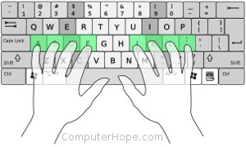**ASDFG :LKJH ASDFG :LKJH**

**ASDFG :LKJH ASDFG :LKJH**

**ASDFG :LKJH ASDFG :LKJH**

**ASDFG :LKJH ASDFG :LKJH**

**ASDFG :LKJH ASDFG :LKJH**

**ASDFG :LKJH ASDFG :LKJH**

**ASDFG :LKJH ASDFG :LKJH**

**TOP ROW PRACTICE WORDS**

**qwer poiu qwer poiu Quail Quart Quilt Quell**

**qwer poiu qwer poiu Turtle Quest Two Forward**

**qwer poiu qwer poiu Figure Grid Operators Words**

**qwer poiu qwer poiu Use Try Year War**

**qwer poiu qwert poiu Pop Pull Fish Frog**

**qwer poiu qwert poiuy Hour Day Weak Wolf**

**qwert poiuy qwert poiuy Lily Out Your Happy**

**qwert poiuy qwert poiuy Hello Holy Wear Rose**

**qwert poiuy qwert poiuy The They Hey Say**

**qwert poiuy qwert poiuy Truth Trust Tripple Rise**

**qwert poiuy qwert poiuy Query Theory This Are**

**qwert poiuy qwert poiuy Row Grapes Last Top**

**QWERT POIUY QWERT POIUY Left Keys Our Tata**

**QWERT POIUY QWERT POIUY Forward**

**QWERT POIUY QWERT POIUY**

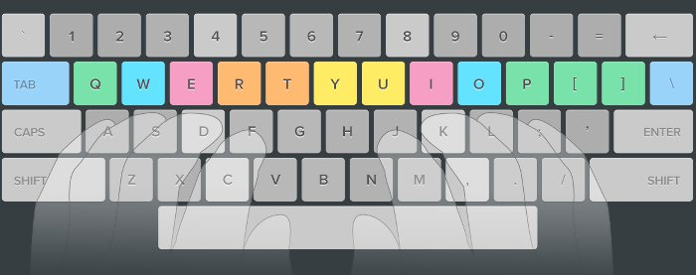**QWERT POIUY QWERT POIUY**

**QWERT POIUY QWERT POIUY**

**QWERT POIUY QWERT POIUY**

**BOTTOM ROW PRACTICE WORDS**

**zxcv /.,m zxcv /.,m Zigzag Zebra Zero**

**zxcv /.,m zxcv /.,m Zipper Zinnia Zoo**

**zxcv /.,m zxcv /.,m Zala Zaddy Zamono**

**zxcv /.,m zxcv /.,m Zakk Zah Zomo**

**zxcv /.,m zxcv /.,m Xenops Xiphias Xerox**

**zxcv /.,m zxcv /.,m Xaps Xan Xaghij**

**zxcvb /.,mn zxcvb /.,mn Xalfo Xalmo Xader**

**zxcvb /.,mn zxcvb /.,mn Cow Corn Cup**

**zxcvb /.,mn zxcvb /.,mn Cone Crony Code**

**zxcvb /.,mn zxcvb /.,mn Cola Coal Cent**

**zxcvb /.,mn zxcvb /.,mn Cat Carp Cart**

**ZXCVB ?><MN ZXCVB ?><MN Card Camel Carrot**

**ZXCVB ?><MN ZXCVB ?><MN Car Cake Carl**

**ZXCVB ?><MN ZXCVB ?><MN Vest Vote Velvet**

**ZXCVB ?><MN ZXCVB ?><MN Valley Van Vowels**

**ZXCVB ?><MN ZXCVB ?><MN Bee Bird Bus**

**ZXCVB ?><MN ZXCVB ?><MN Balloon Bag Big**

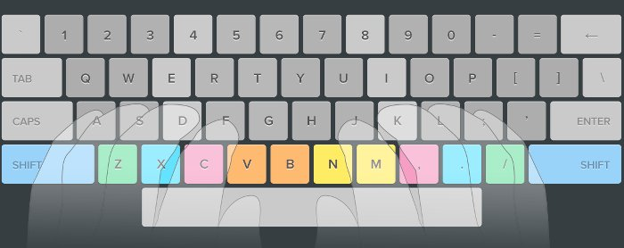Word processors evolved dramatically once they became software programs rather than dedicated machines. They can usefully be distinguished from text editors, the category of software they evolved from. Word processing added to the text editor the ability to control type style and size, to manage lines (word wrap), to format documents into pages, and to number pages. Functions now taken for granted were added incrementally, sometimes by purchase of independent providers of add-on programs. Spell checking, grammar checking and mail merge were some of the most popular add-ons for early word processors. Word processors are also capable of hyphenation, and the management and correct positioning of footnotes and endnotes. Later desktop publishing programs were specifically designed with elaborate pre-formatted layouts for publication, offering only limited options for changing the layout, while allowing users to import text that was written using a text editor or word processor, or type the text in themselves.

A data entry clerk is a member of staff employed to enter or update data into a computer system. Data is often entered into a computer from paper documents using a keyboard. The keyboards used can often have special keys and multiple colors to help in the task and speed up the work. Proper ergonomics at the workstation is a common topic considered. The Data Entry Clerk may also use a mouse, and a manually-fed scanner may be involved. Speed and accuracy, not necessarily in that order, are the key measures of the job; it is possible to do this job from home.

Two common terms used to describe a salesperson are 'Farmer' and 'Hunter'. The reality is that most professional salespeople have a little of both. A hunter is often associated with aggressive personalities who use aggressive sales technique. In terms of sales methodology, a hunter refers to a person whose focus is on bringing in and closing deals. This process is called 'sales capturing'. An example is a commodity sale such as a long distance salesperson, shoe salesperson and to a degree a car salesperson. Their job is to find and convert buyers. A sales farmer is someone who creates sales demand through activities that directly influence and alter the buying process.

Self-confidence is a tricky subject for many people. For some, it's impossible to feel good about themselves without outside validation. When you're in a situation where the people in your life aren't helping you to feel better about yourself, this can become a problem in your day to day life. Most insecurity stems from feelings of not being attractive or feelings of loneliness. If your insecurity doesn't necessarily stem from a lack of interaction, but more a lack of feeling attractive, there are other options that will help you online. Sometimes the best way to put your insecurities to rest can simply be to get an honest opinion. There are multiple support groups online where you can share a picture of yourself with other members and they will give honest feedback on your appearance. In most cases, they will point out good qualities that you may have missed in yourself. But you can trust them to be honest and many members give very valuable style and posture advice to increase your attractiveness. These practical tips and unbiased opinions from supportive strangers will immediately help you feel better about yourself, and if the tips are implemented it will also improve your self-esteem in the long-run.

One morning my friend and I were thinking about how we could plan our summer break away from school. Driving from our own state to several nearby states would help to expand our limited funds. Inviting six other friends to accompany us would lower our car expenses. Stopping at certain sites would also help us stretch our truly limited travel budget. Yesterday I engaged in an interesting and enlightening discussion about finances. I found it difficult to imagine that during my lifetime I might well earn at least one-half million dollars. It is also possible that I might spend as much as one-half million during the same period. The really difficult thing for me to do will be to save more of the half-million than I spend. Thinking about today's high cost of living makes this seem an impossible task for most. Last week I asked a friend to talk with me and a girl-friend about college. Our friend is the Dean of Women at a nearby college. The Dean and her staff spend much of their time talking to students who plan to go to college. The first thing she said was to work very hard each day in high school. Good grades are most important for being accepted. Being on time for classes and having a good view toward all phases of the school life are two other things to remember.

The bikers rode down the long and narrow path to reach the city park. When they reached a good spot to rest, they began to look for signs of spring. The sun was bright, and a lot of bright red and blue blooms proved to all that warm spring days were the very best. Spring rides were planned. They had a burger at the lake and then rode farther up the mountain. As one rider started to get off his bike, he slipped and fell. One of the other bikers saw him fall but could do nothing to help him. Neither the boy nor the bike got hurt. After a brief stop, everyone was ready to go on. All the bikers enjoyed the nice view when they came to the top. All the roads far below them looked like ribbons. A dozen or so boats could be seen on the lake. It was very quiet and peaceful and no one wished to leave. As they set out on their return, they all enjoyed the ease of pedaling. The bikers came upon a new bike trail. This route led to scenery far grander than that seen from the normal path. The end of the day brought laughs and cheers from everyone. The fact that each person was very, very tired did not keep anyone from eagerly planning for the exciting ride to come.

Hunt and peck (two-fingered typing), also known as Eagle Finger, is a common form of typing in which the typist presses each key individually. Instead of relying on the memorized position of keys, the typist must find each key by sight. Use of this method may also prevent the typist from being able to see what has been typed without glancing away from the keys. Although good accuracy may be achieved, any typing errors that are made may not be noticed immediately due to the user not looking at the screen. There is also the disadvantage that because fewer fingers are used, those that are used are forced to move a much greater distance.

**Basic TallyERP9 Syllabus**

**1 Introduction**

  1.1 Full Form of Tally ERP9

  1.2 History of TallyERP9

**2 Company Information**

  2.1 Create company

  2.2 Alter company

  2.3 Select company

  2.4 Delete Company

  2.5 Shut Company

**3 Gateway of Tally**

  3.1 Introduction of Gateway of Tally

**4 Accounts Info.**

  4.1 Create Ledger

  4.2 Create Multiple Ledger

  4.3 Configuration of Ledger

**5 Chart of Accounts**

**6 Feeding Opening Balance**

  6.1 creating Ledger

  6.2 Balance Sheet question

**7 voucher Entries**

  7.1 Accounts Only/ Double Mode

  7.2 Journal Entry question

  7.3 Configuration of voucher Entry

**8 Bill Reference**

**9 Display of Accounting Voucher**

  9.1 Day Book and Configuration

**10 single Mode Voucher Entries**

**11 Inventory Info.**

  11.1 Create Stock Group

  11.2 Create Stock Item

  11.3 Create UOM

**12 Inventory Voucher**

  12.1 Subsidiary Book question

**13 Common/ General Configuration**

**14 Company Data**

  14.1 Backup

  14.2 Restore

**15 Ledger Auditing and Correction of Error**

**16 Report Display**

  16.1 Trial Balance and configuration

  16.2 Balance sheet and Configuration

**17 Bank Reconcilation**

**18 Cost Center**

**19 Printing**

  19.1 voucher Printing

  19.2 Report Printing

19.3 Multi-Account Printing

**20 Export Tally Data**

**Tally ERP9 Shortcut**

**Common Shortcuts:-**

**Window + E** = My files

**Enter** = Drill Down

**Esc** = One Step Back

**Ctrl + A** = Quick Save

**Ctrl + Q** = Quit

**F11** = Features

**F12** = Configuration

**Alt + P** = Print

**Gateway of Tally:-**

**F1** = Select Company

**Alt + F1** = Shut Company

**F2** = Date

**Alt + F2** = Period

**Alt + F3** = Company Info.

**F11** = Features

**F12** = Configuration

**Ctrl + N** = Calculator

**Ctrl + M** = Active Main Screen

**Alt + K** = Keyboard

**Alt + G** = Language

**Alt + H** = Help

**Shift + B / B** = Balance Sheet

**Shift + P / P** = Profit & Loss A/c

**Shift + S / S** = Stock Summary

**Alter of Company Screen:-**

**Alt + D** = Delete Company

**Group Creation/ Display:-**

**Ctrl + L** = Ledger Create

**Ctrl + V** = Voucher Types

**F11** = Features

**F12** = Configuration

**Alteration of Group:-**

**F10** = Skip/ Edit Sort

Same as Group Creation/ Display Screen Shortcuts

**Multi Group Creation/ Display:-**

**F4** = Parent

**Ctrl + L** = Ledgers

**F11** = Features

**Alteration of Multi Group:-**

**F4** = Parent

**Ctrl + F4** = New Parent/ List of groups

**F6** = Skip Name

**F7** = Skip Parent

**F10** = Skip Sort

**Ctrl + L** = Ledger

**F11** = Features

**Ledger Creation / Display:-**

**Ctrl + G** = Group Create

**Ctrl + V** = Voucher Type

**F11** = Features

**F12** = Configuration

**Ledger Alteration:-**

**F10** = Skip sort

**Ctrl + G** = Group

**Ctrl + V** = Voucher Type

**F11** = Features

**F12** = Configuration

**Multi Ledger Creation:-**

**F4** = Parent

**F8** = Skip Details

**Ctrl + G** = Groups

**F11** = Features

**Multiple Ledger Display:-**

**Ctrl + F4** = New Parent

**Ctrl + G** = Groups

**F11** = Features

**Multi Ledger Alteration:-**

**F4** = Parent

**Ctrl + F4** = New Parent

**Alt + Z** = Zero Opening Balance

**F6** = Skip Names

**F7** = Skip Parent

**F8** = Skip Detail

**F10** = Skip Sort

**Ctrl + G** = Group

**F11** = Features

**Voucher Type Creation/ Display:-**

**Ctrl + G** = Group

**Ctrl + V** = Ledger

**F11** = Features

**F12** = Configuration

**Alteration of Voucher Type:-**

**F10** = Skip Sort

Same as Voucher Type Creation

**Accounting Voucher Creation:-**

**Alt + F1** = Inventory Voucher

**F2** = Date

**F4** = contra

**F5** = Payment

**F6** = Receipt

**F7** = Journal

**F8** = Sales

**F9** = Purchase

**F10** = Reversing Journal

**Ctrl + F10** = Memos

**Ctrl + L** = Optional Voucher

**Ctrl + T** = Post-Dated

**F11 =** Features

**F12 =** Configuration

**Alt + C =** Ledger Creation

**Alt + I =** Name of Particular/ Name of Items (Only Sales & Purchase Voucher)

**Ctrl + V =** Single/ Double Mode (Only Sales & Purchase Voucher)

**Shift + Tab/Backspace/ Up Arrow=** Change Voucher Date

**Alt + R =** Carry Narration of Similar Voucher

**Ctrl + R =** Carry Ledger of similar Voucher

**Ctrl + Left/ Ctrl + Right Arrow=** To Jump one word at a time Left/ Right in voucher narration.

**Ctrl + Enter =** Master Alteration

**Ctrl + F8 =** Credit Note (Sale Return)

**Ctrl + F9 =** Debit Note (Purchase Return)

**Day Book Report:-**

**Alt + F1** = Detailed/ Condensed

**F2** = Date

**Alt + F2** = Period

**F4** = Change Voucher/ List of Voucher Types

**Alt + T** = Post Dated Transactions

**F9** = List of Inventory Reports

**F10** = List of Accounting Reports

**F11** = Features

**F12** = Configuration

**Alt + F12** = Range

**Alt + I** = Insert Voucher

**Alt + A** = Add Voucher

**Alt + 2** = Duplicate Voucher

**Alt + R** = Hide Entry

**Alt + U** = Unhide Entry

**Ctrl + U** = Unhide All Entries

**Alt + D** = Delete

**Alt + X** = Cancel Voucher

**Ctrl + Space** = Select All Voucher Entry at a time

**Space + Up/ Down Arrow** = Select Voucher

**Plus(+)** = Next Date

**Minus(-)** = Previous Date

**Alt + P** = Print Day Book

**Enter**  = Alteration of Voucher Entry

**Trial Balance:-**

**Alt + F1** = Detailed/ Condensed

**Alt + F2** = Period

**F4** = Group/ List of Group

**F5** = Ledger-wise/ Grouped

**F7** = Voucher

**Alt + C** = New Column

**Alt + A** = Alter Column

**F8** = Related Report/ List of Report

**F9** = Inventory Reports

**F10** = Accounting Report

**F11** = Features

**F12** = Configuration

**Alt + F12** = Range

**Ctrl + F12** = Value

**Alt + N** = Auto Column

**Group Summary:-**

**F6** = Monthly

**Alt + P** = Print

Same as Trial Balance

**List of Accounts:-**

**Ctrl + G** = Group

**Ctrl + L** = Ledger

**Ctrl + E** = Currencies

**Ctrl + T** = Stock Group

**Ctrl + K** = Stock Categories

**Alt + N** = Units

**Ctrl + O** = Godowns

**Ctrl + V** = Voucher Types/ List of Voucher Types

**F5** = Show Unused

**F11** = Features

**Alt + F12** = Range

**Stock Summary:-**

**Alt + F1** = Detailed/ Condensed

**Alt + F2** = Period

**F4** = Group

**F5** = Item-Wise

**F7** = Show Profit

**Alt + C** = New Column

**Alt + A** = Alter Column

**Alt + N** = Auto Column

**F9** = Inventory Reports

**F10** = Accounting Report

**F11** = Features

**F12** = Configuration

**Alt + F12** = Range

**Ctrl + F12** = Value

**Ratio Analysis:-**

**Alt + F2** = Period

**Alt + C** = New Column

**Alt + A** = Alter Column

**Alt + N** = Auto Column

**F9** = Inventory Reports

**F10** = Accounting Reports

**F11** = Features

**F12** = Configuration

**Alt + F12** = Range

**Ctrl + F12** = Value

**Cash/ Bank Book Summary:-**

**Alt + F1** = Detailed/ Condensed

**Alt + F2** = Period

**F4** = Group

**F5** = Ledger-wise

**Alt + C** = New Column

**Alt + A** = Alter Column

**Alt + N** = Auto Column

**F9** = Inventory Reports

**F10** = Accounting Reports

**F11** = Features

**F12** = Configuration

**Alt + F12** = Range

**Ctrl + F12** = Value

**Voucher Register (Sales, Purchase, Journal Registers):-**

**Alt + F2** = Period

**F4** = Voucher Type/List of Voucher Types

**Alt + F5** = Quarterly

**Alt + C** = New Column

**Alt + A** = Alter Column

**Alt + N** = Auto Column

**F9** = Inventory Reports

**F10** = Accounting Reports

**F11** = Features

**F12** = Configuration

**Ctrl + F12** = Value

**Receipts And Payments:-**

**Alt + F1** = Detailed/ Condensed

**Alt + F2** = Period

**F5** = Ledger-wise

**Alt + C** = New Column

**Alt + N** = Alter Column

**Alt + A** = Auto Column

**F9** = Inventory Reports

**F10** = Accounting Reports

**F11** = Features

**F12** = Configuration

**Alt + F12** = Range

**Ctrl + F12** = Value

**Cash Flow/ Fund Flow:-**

Same as Voucher Register Shortcut except F4.

**Cash Flow Projection:-**

**Alt + F1** = Detailed/ Condensed

**Alt + F2** = Period

**Alt + N** = Auto Column

**F9** = Inventory Reports

**F10** = Accounting Reports

**F11** = Features

**F12** = Configuration

**Bill Receivable/ Bill Payable:-**

**Alt + F1** = Detailed/ Condensed

**Alt + F2** = Period

**F4** = Payable/ Receivable

**F6** = Age Wise/ Ageing Method

**Alt + F7** = Bill-wise

**F9** = Inventory Report

**F10** = Accounting Reports

**F11** = Features

**F12** = Configuration

**Alt + F12** = Range

**Group Outstanding:-**

**Alt + F7** = Bill-Party Wise

Same As Group Summary

**Statistics:-**

Same As Ratio Analysis:-

**Inventory Voucher Creation/ Display/ Alteration:-**

**F1** = Accounting Voucher

**F2** = Date

**Alt + F10** = Physical Stock

**Alt + F7** = Stock Journal

**Ctrl + T** = Post- Dated

**F11** = Features

**F12** = Configuration

**Stock Group Creation/ Display/ Alteration:-**

**Ctrl + I** = Items

**Ctrl + U** = Units

**Ctrl + V** = Voucher Types

**F11** = Features

**F12** = Configuration

**Multi Stock Group Creation:-**

**F4** = Parents

**F8** = Skip Detail

**Ctrl + I** = Items

**F11** = Features

**Multi Stock Group Display:-**

**Ctrl + F4** = New Parent

**Ctrl + I** = Items

**F11** = Features

**Multi Stock Group Alter:-**

**F4** = Parent

**Ctrl + F4** = New Parent

**F6** = Skip Names

**F7** = Skip Parent

**F8** = Skip Details

**Ctrl + I** = Items

**F11** = Features

**Stock Item Creation/ Display/ Alteration:-**

**Ctrl + G** = Group

Same As Stock Group Creation

**Multi Stock Items Creation:-**

**F4** = Parents

**F8** = Skip Details

**F9** = Skip Category

**Ctrl + G** = Group

**F11** = Features

**Multi Stock Items Display:-**

**Ctrl + F4** = New Parent

**Ctrl + G** = Group

**F11** = Features

**Multi Stock Items Alteration:-**

**F4** = Parent

**Ctrl + F4** = New Parent

**Alt + Z** = Zero Opening Balance

**F6** = Skip Name

**F7** = Skip Parent

**F8** = Skip Details

**F9** = Skip Category

**Ctrl + G** = Group

**F11** = Features

**Unit Of Measure Creation/ Display/ Alteration:-**

**Ctrl + G** = Group

**Ctrl + I** = Items

**Ctrl + V** = Voucher Types

**F11** = Features

**Voucher Types Creation/ Display:-**

**Ctrl + G** = Groups

**Ctrl + L** = Ledger

**F11** = Features

**F12** = Configuration

**Voucher Types Alteration:-**

**F10** = Skip Sort

Same As Voucher Types Creation

**Negative Stock Items:-**

**Alt + F1** = Detailed/ Condensed

**Alt + F2** = Period

**F4** = Group/ List of Groups

**F5** = Grouped/ Item-wise

**F7** = Show Profit/ Hide Profit

**Alt + C** = New Column

**Alt + N** = Auto Column

**Alt + A** = Alter Column

**F9** = Inventory Report

**F10** = Accounting Report

**F11** = Features

**F12** = Configuration

**Alt + F12** = Range

**Ctrl + F12** = Value

**Negative Ledger Accounts:-**

Same as Negative Stock Accounts

**Memorandum Register:-**

Same as Voucher Register

**Voucher Register/ Post Dated Voucher:-**

**F2** =Date

**Alt + F2** = Period

**F4** = Change Voucher

**Alt + T** = Post-Dated Report

**F9** = Inventory Report

**F10** = Accounting Report

**F11** = Features

**F12** = Configuration

**Alt + F12** = Range

**Post-Dated Transaction:-**

**Alt + F1** = Detailed

**Alt + F2** = Period

**F4** = Ledger

**Alt + F4** = Alter Bank

**F6** = Show Pending

**Alt + A** = New Date

**Alt + K** = Enter Note

**Alt + S** = Quick Search

**F10** = Accounting Report

**F11** = Features

**F12** = Configuration

**Alt + F12** = Range

**Stock Query:-**

**Alt + F2** = Period

**F4** = Item/ List of Items

**F5** = Show State Info.

**Ctrl + F7** = Top Buyers/ Sellers

**F8** = Related Reports

**F9** = Inventory Reports

**F10** = Accounting Reports

**F11** = Features

**F12** = Configuration

**Item Estimation:-**

**Alt + F1** = Detailed

**Alt + F2** = Period

**F4** = Group

**F5** = Show all BOM

**F6** = Components-wise

**F9** = Inventory Report

**F10** = Accounting Report

**F11** = Features

**F12** = Configuration

**Alt + F12** = Range

**Stock Items:-**

Same As Voucher Register

**Physical Stock Register:-**

Same As Voucher Register

**Stock Ageing Analysis:-**

**Alt + F1** = Detailed

**Alt + F2** = Period

**F4** = Group

**F6** = Ageing Period

**F7** = Valuation

**Alt + A** = Hide Amount

**Alt + D** = Delete Column

**F9** = Inventory Report

**F10** = Accounting Report

**F11** = Feature

**F12** = Configuration

**Alt + F12** = Range

**Printing:-**

**Alt + L** = Print Language

**Alt + I** = Preview/ No Preview

**Alt + T** = Titling

**Ctrl + G** = Page Nos.

**Alt + R** = Plain Paper/ Pre-printed

**Alt + C** = Copies/ No. Of Copies

**Alt + S** = Select Printer

**F12** = Configuration

**Alt + F** = Print format

**Alt + N** = Auto Column

**F4/ Alt + Z** = Zoom

**Bank Reconcilation:-**

**F2** = Period

**Alt + S** = Set Bank Date

**Alt + C** = Create Voucher

**Alt + U** = Opening BRS

**F11** = Features

**F12** = Configuration

**Alt + F12** = Range

**Tally Groups**

|  |  |  |  |
| --- | --- | --- | --- |
| **Sr. No.** | **Ledger Name** | **-** | **Group Name** |
| 1 | **Capital** | - | Capital Account |
| 2 | **Drawing** | - | Capital Account |
| 3 | **Opening Stock** | - | Stock-in-Hand |
| 4 | **Purchase** | - | Purchase Account |
| 5 | **Purchase Return** | - | Purchase Account |
| 6 | **Return Onward** | - | Purchase Account |
| 7 | **Sales** | - | Sales Account |
| 8 | **Sales Return** | - | Sales Account |
| 9 | **Return Inward** | - | Sales Account |
| 10 | **Sundry Creditor** | - | Sundry Creditor |
| 11 | **Suppliers** | - | Sundry Creditor |
| 12 | **Sundry Debtors** | - | Sundry Debtors |
| 13 | **Customer** | - | Sundry Debtors |
| 14 | **Bank** | - | Bank Account |
| 15 | **Bank Deposit** | - | Bank Account |
| 16 | **Bank Overdraft** | - | Bank OD |
| 17 | **Investments** | - | Investments |
| 18 | **Fixed Deposit** | - | Investments |
| 19 | **Loan** | - | Loan Liabilities |
| 20 | **Loan from Bank** | - | Loan Liabilities |
| 21 | **Bill Payable** | - | Current Liabilities |
| 22 | **Sales Tax Collected** | - | Duties & Taxes |
| 23 | **Outstanding Exp.** | - | Current Liabilities |
| 24 | **Bill Receivable** | - | Current Assets |
| 25 | **Prepaid Exp.** | - | Current Assets |
| 26 | **Furniture** | - | Fixed Assets |
| 27 | **Land & Building** | - | Fixed Assets |
| 28 | **Plant & Machinery** | - | Fixed Assets |
| 29 | **Patents** | - | Fixed Assets |
| 30 | **Free Hold Property** | - | Fixed Assets |
| 31 | **Lease Hold Building** | - | Fixed Assets |
| 32 | **Motor Car** | - | Fixed Assets |
| 33 | **Houses & Carts** | - | Fixed Assets |
| 34 | **Trade Marks** | - | Fixed Assets |
| 35 | **Goodwill** | - | Fixed Assets |
| 36 | **Business Premises** | - | Fixed Assets |
| 37 | **Rent** | - | Indirect Exp. |
| 38 | **Discount Allowed** | - | Indirect Exp. |
| 39 | **Carriage Outward** | - | Indirect Exp. |
| 40 | **Freight Outward** | - | Indirect Exp. |
| 41 | **Travelling Exp.** | - | Indirect Exp. |
| 42 | **Salaries** | - | Indirect Exp. |
| 43 | **Interest On Loan** | - | Indirect Exp. |
| 44 | **Insurance Premium** | - | Indirect Exp. |
| 45 | **Advertisement** | - | Indirect Exp. |
| 46 | **Trade Exp.** | - | Indirect Exp. |
| 47 | **Bad-Debts** | - | Indirect Exp. |
| 48 | **Charity** | - | Indirect Exp. |
| 49 | **Donation** | - | Indirect Exp. |
| 50 | **Deprecation** | - | Indirect Exp. |
| 51 | **Interest On Capital** | - | Indirect Exp. |
| 52 | **Carriage On Sales** | - | Indirect Exp. |
| 53 | **General Exp.** | - | Indirect Exp. |
| 54 | **Bank Charges** | - | Indirect Exp. |
| 55 | **Free Samples** | - | Indirect Exp. |
| 56 | **Interest Received** | - | Indirect Exp. |
| 57 | **Interest** | - | Interest Paid |
| 58 | **Carriage on Purchase** | - | Direct Exp. |
| 59 | **Wages** | - | Direct Exp. |
| 60 | **Carriage Inward** | - | Direct Exp. |
| 61 | **Freight Outward** | - | Direct Exp. |
| 62 | **Discount Received** | - | Indirect Income |
| 63 | **Interest on Investment** | - | Indirect Income |
| 64 | **Bed-Debts Recovered** | - | Indirect Income |
| 65 | **Commission Received** | - | Indirect Income |
| 66 | **Interest on Drawing** | - | Indirect Income |
| 67 | **Sales Tax** | - | Duties & Taxes |
| 68 | **VAT Paid** | - | Duties & Taxes |
| 69 | **VAT Collected** | - | Duties & Taxes |
| 70 | **GST** | - | Duties & Taxes |

Tally ERP9

**Q- Full form of Tally ERP9**

T= Total E= Enterprise

A= Accounting R= Resource

L= Leading P= Planning

L= List

Y= Year

**Q- Version of Tally**

Tally 4.5

Tally 5.4

Tally 6.3

Tally 7.2

Tally 8.1

Tally 9.0

Tally ERP9

Tally Prime

**Q- How to create company?**

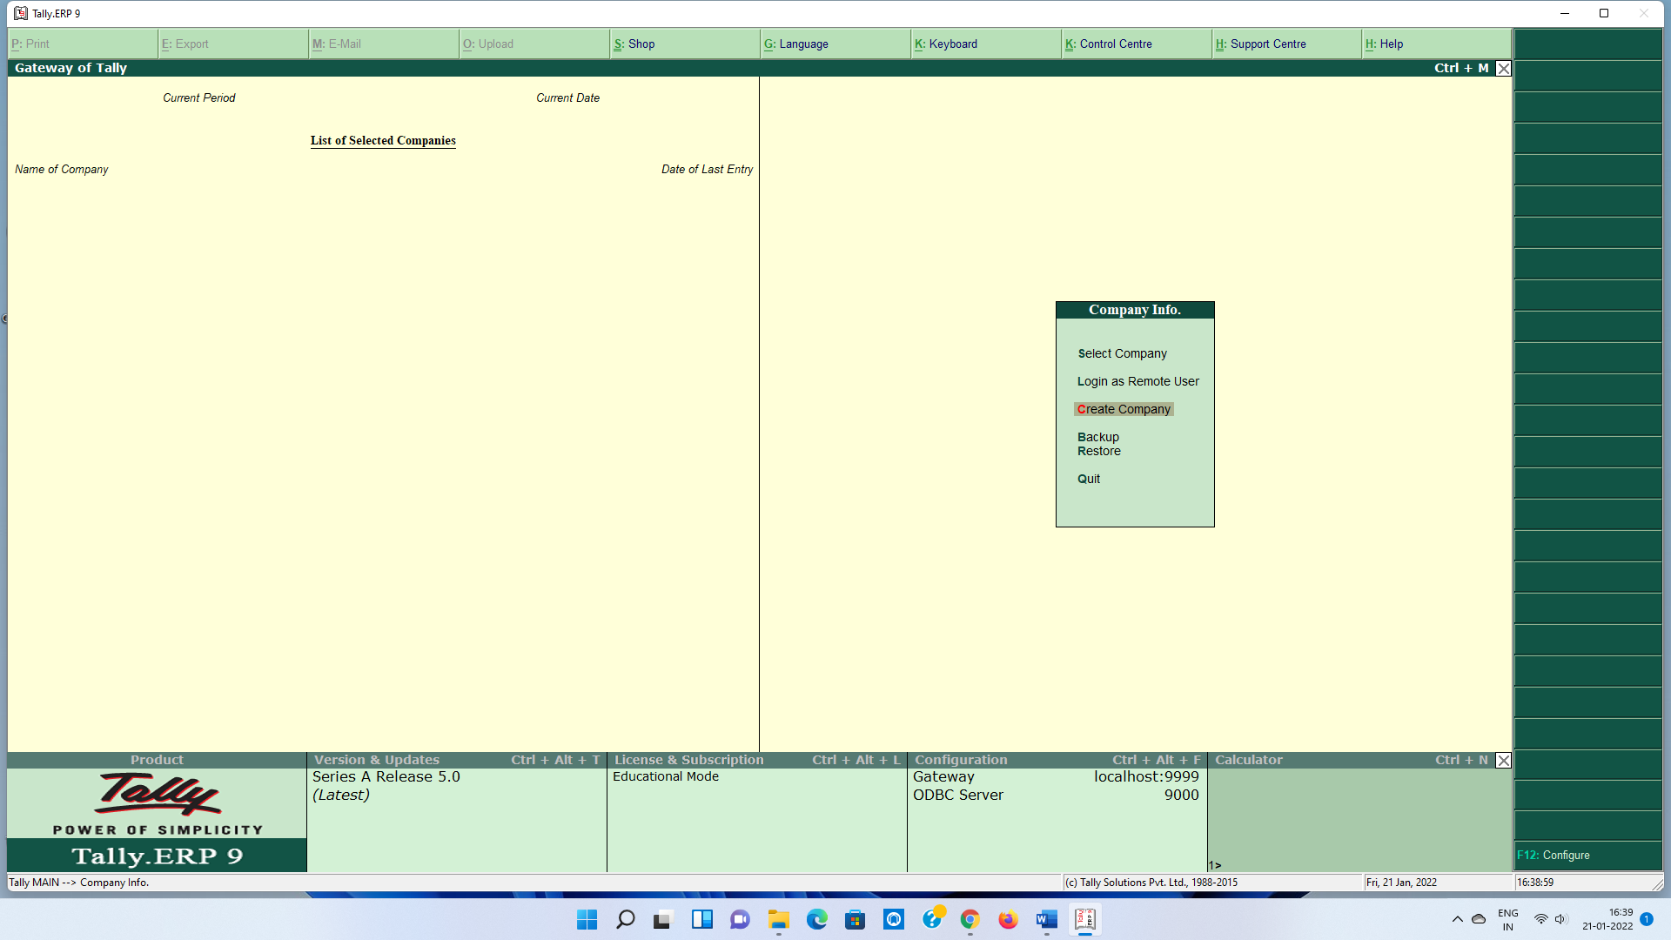

**Q- How to alter any Company?**

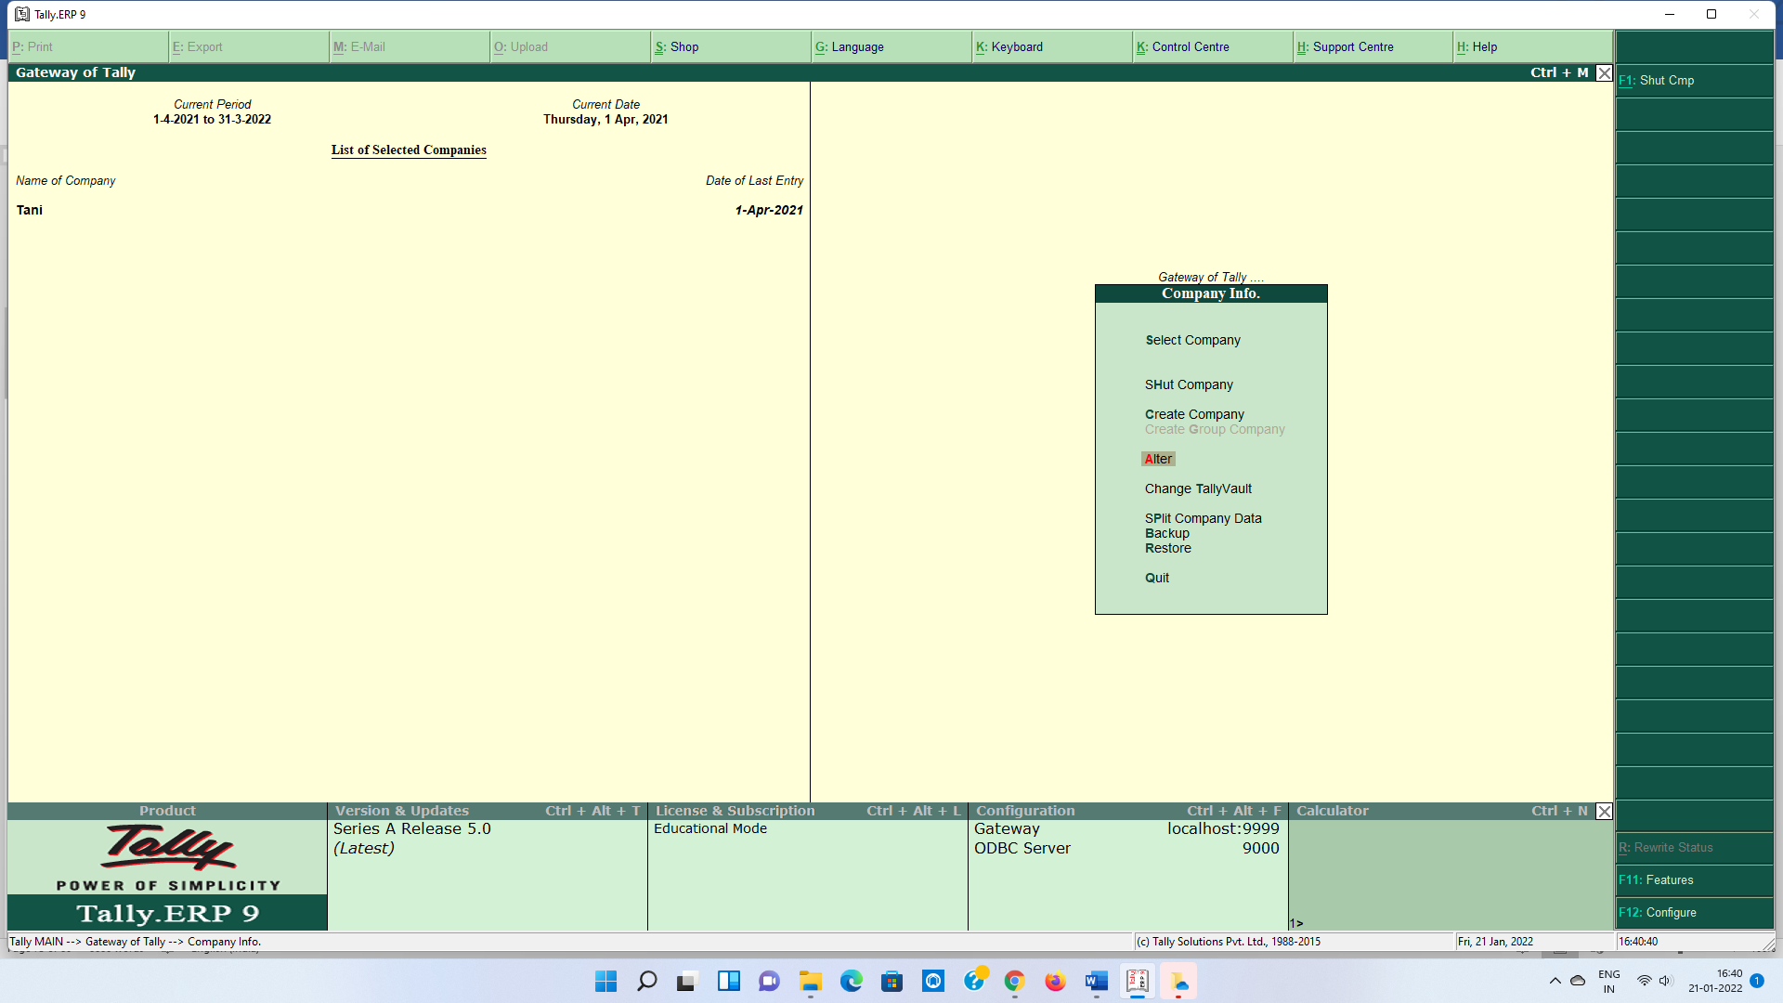

**Q- How to select company?**

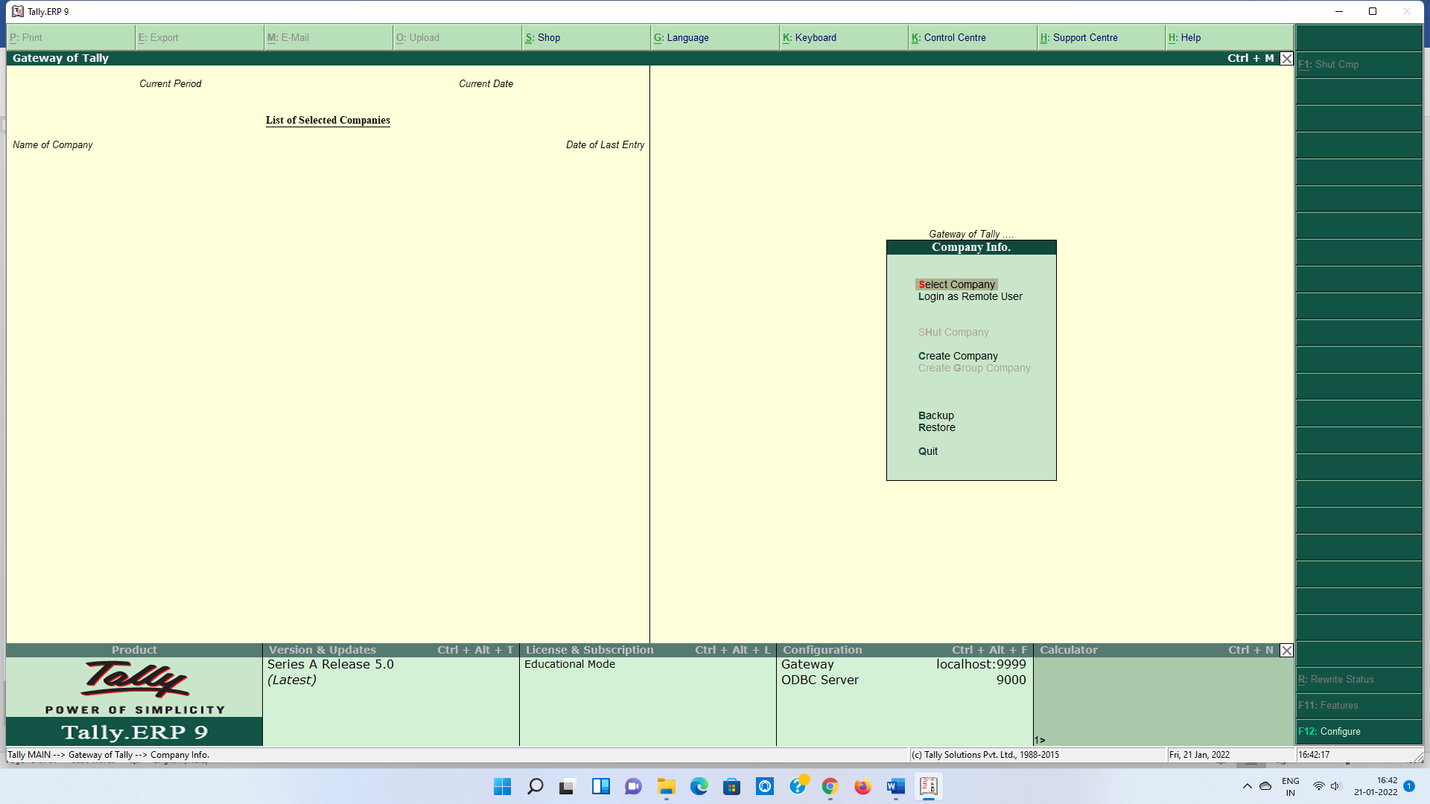

Gateway of Tally

🡫

F1

**Q- How to Shut company?**

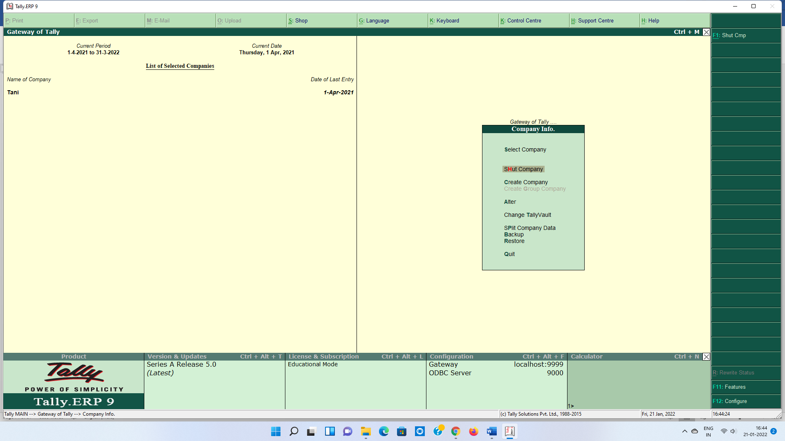

**Q- We work in education mode..**

Only three date are entered (1,2 or 31)

**Q- How to delete company?**

|  |
| --- |
| Company Inf.  🡫  Alter  🡫  List of Company  🡫  Select Company  🡫  Alt + D  🡫  Yes  🡫  Yes |

**Q- How to create/Alter/Delete Ledger?**

|  |
| --- |
| Gateway of Tally  🡫  Accounts Info.  🡫  Ledger  🡫  Create/Alter/Delete |

**Q- Reserved Ledger**

2 Ledger (P/L & Cash)

**Q- How to Create/ Alter/ Delete Group?**

|  |
| --- |
| Gateway of Tally  🡫  Accounts Info.  🡫  Group  🡫  Create/Alter/Delete |

**Q- Reserved Groups**

28 Groups

15 (Primary) 13(Subgroup)

**Q- Vouchers Entries**

* **F4:- Contra**
  + Cash Deposit into Bank
  + Withdraw Cash from the Bank
* **F5:- Payment**
  + Payment through Cash or Bank
* **F6:- Receipt**
  + Receive through Cash or Cheque or Bank Transfer
* **Journal**
  + Adjustment Entries (Where no cash or bank A/c is Dr. or Cr.)
* **F8:- Sales**
  + Sale through Cash or on Credit also
* **F9:- Purchase**
  + Purchase through Cash or on Credit also

Hindi Typing

**Without Caps lock**

**q w e r t y u i o p [ ]**

**a s d f g h j k l ; ‘**

**z x c v b n m , . /**

**With Shift Key**

**Q W E R T Y U I O P { } |**

**A S D F G H J K L : “**

**Z X C V B N M , > ?**

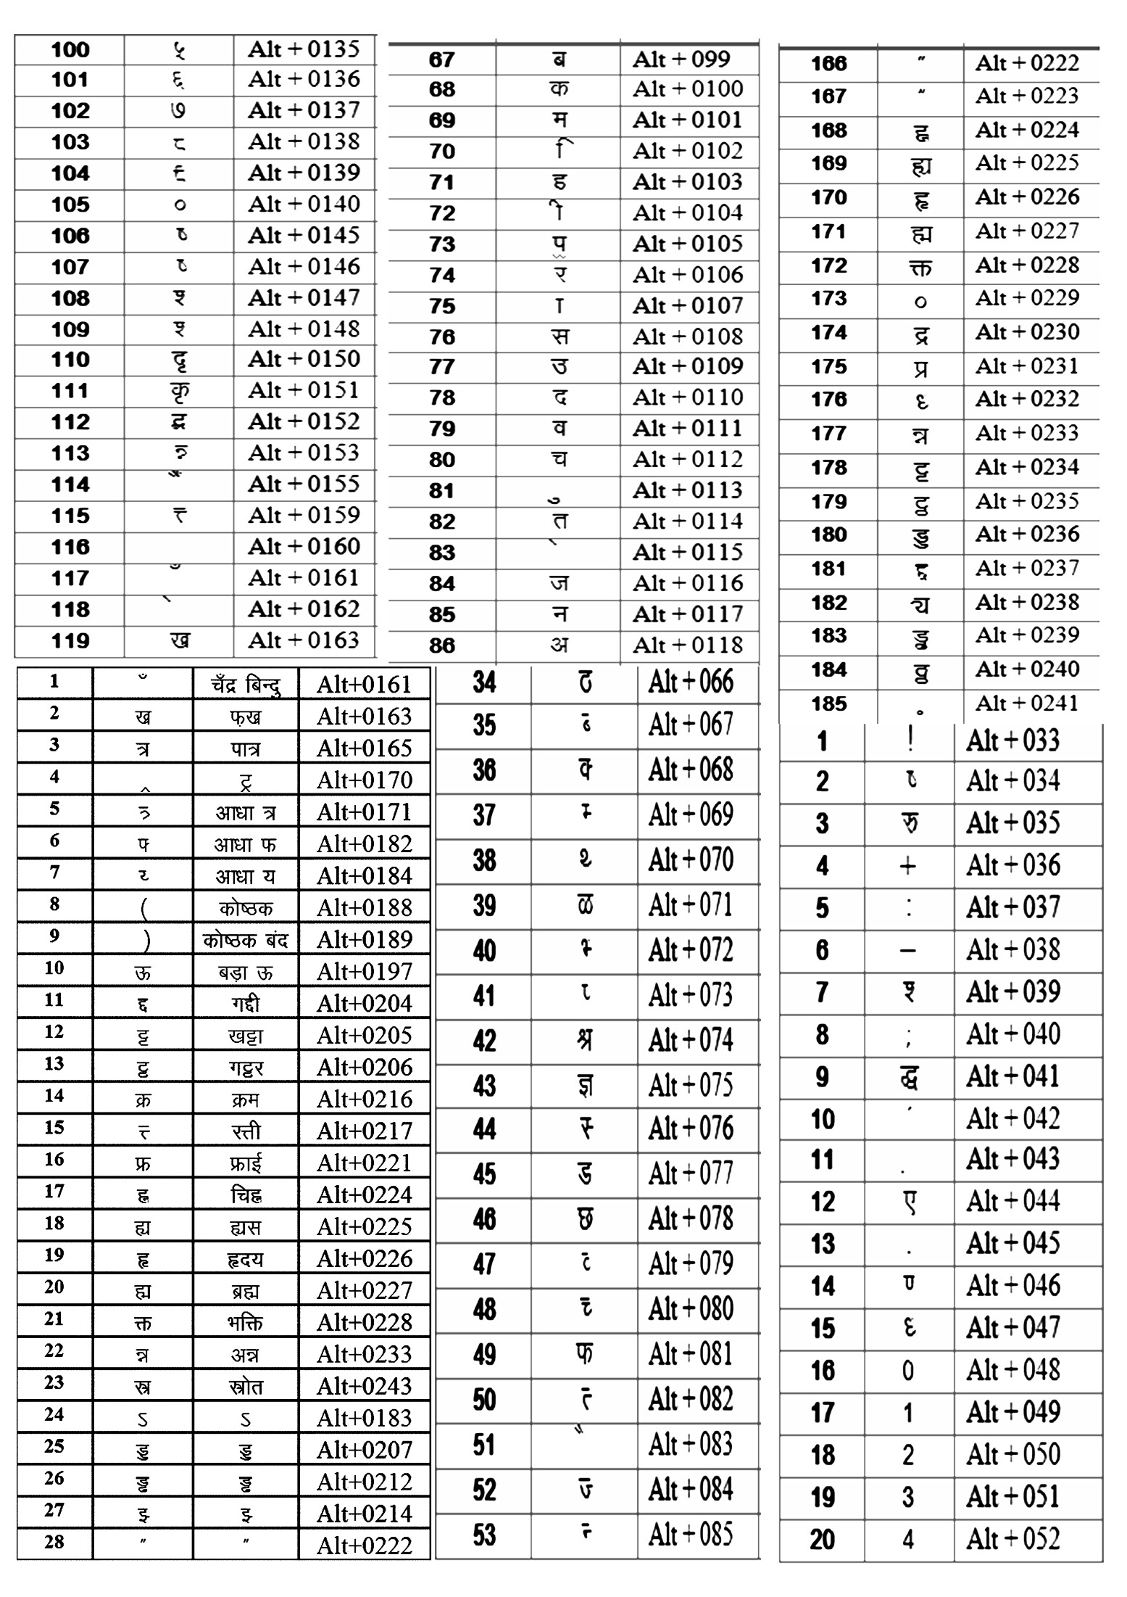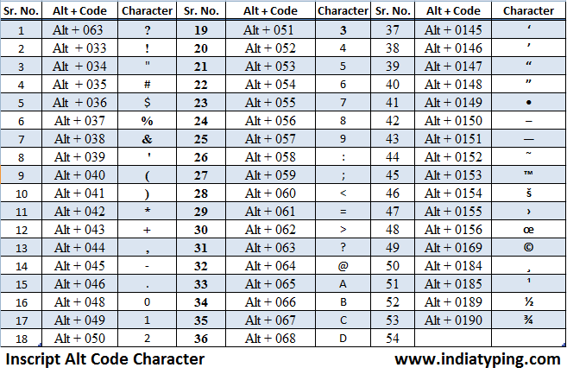

**Home Row Practice Words**

**dg**

**lhj**

**dkl**

**dksjk**

**f’kdkjh**

**lkfjdk**

**lgkjk**

**dgkj**

**dfg;s**

**gks’k**

**jksfd;s**

**ghjk**

**dkj**

**‘kh’k**

**lkjk**

**Jh**

**Hkh**

**Fkh**

**:**

**dkL;**

**gkFk**

**Js;**

**dDdk**

**gDdk**

**gfFk;k**

**fdLlk**

**L;kgh**

**:fd;s**

**Hkjh;s**

**Js;l**

**fdlds**

**jLlh**

**gkL;**

**dFkk**

**dks”k**

**Top Row Practice Words**

**er**

**ty**

**peu**

**tyu**

**rhjFk**

**Hkjuh**

**djuh**

**pedhyk**

**tythjk**

**ekekth**

**ueLrs**

**Hkjiwj**

**tuer**

**ugkrh**

**etkj**

**euekuh**

**eyey**

**iku**

**puk**

**ikuh**

**d{kk**

**{kek**

**eEeh**

**lR;k**

**dSEil**

**lIrkg**

**O;ogkj**

**lkekftd**

**lkIrkfgd**

**irywu**

**pkpk**

**dPpk**

**yYyk**

**lR;**

**i{kh**

**I;kl**

**I;kj**

**i{kh**

**lkgl**

**Bottom Row Practice Words**

**xzg**

**czg**

**/kzqo**

**vxz**

**/;ku**

**bZdkbZ**

**b/kj**

**,dkxzrk**

**mdlkuk**

**jkek;.k**

**vtxj**

**cjxn**

**vuqØe**

**,dk,d**

**/kuoku**

**m/kj**

**b/kj**

**/ku**

**jktsUnz**

**fBdkuk**

**>j>j**

**Bgkdk**

**>juk**

**VekVj**

**VeVe**

**?ku?kksj**

**vark{kjh**

**?keaM**

**>aMk**

**<Ddu**

**VjkZuk**

**ck/kk**

**?keaMh**

**pkSdh**

**NIiu Hkksx**

**?kfV;k**

**<iksj’ka[k**